Zoom & Google Classroom Troubleshooting with Students

- Open Chrome Web browser by double clicking on the icon
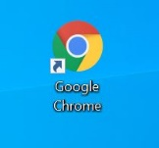

- Type into the browser: uncommonschools.onelogin.com
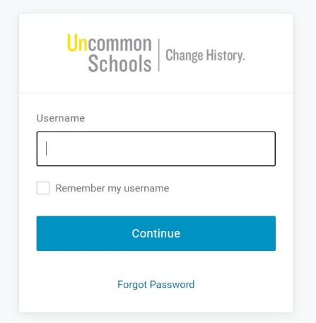

- Type in the username, click the “remember my username button,” then hit continue.
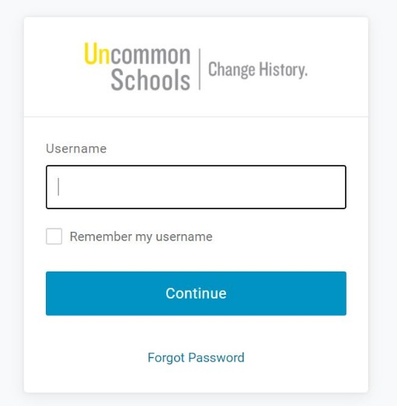

- Type in the password in the password box. Remember that passwords are case sensitive!

- Click the “Keep me signed in,” button then click Continue.
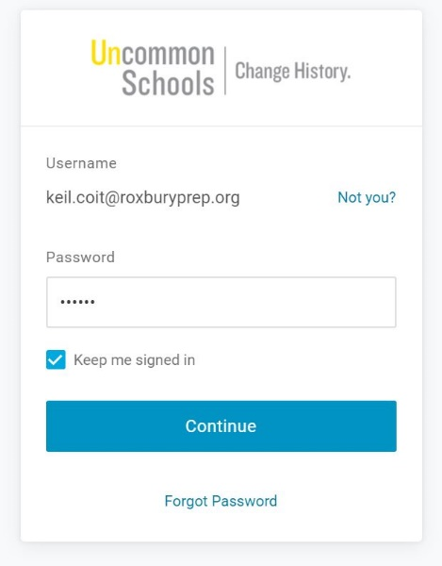

- This will bring students to their “student portal” page. From here they can click on their Google Drive or Zoom. If they are struggling with Zoom, go to number 7. If they are struggling with Google Classroom, go to number 10.
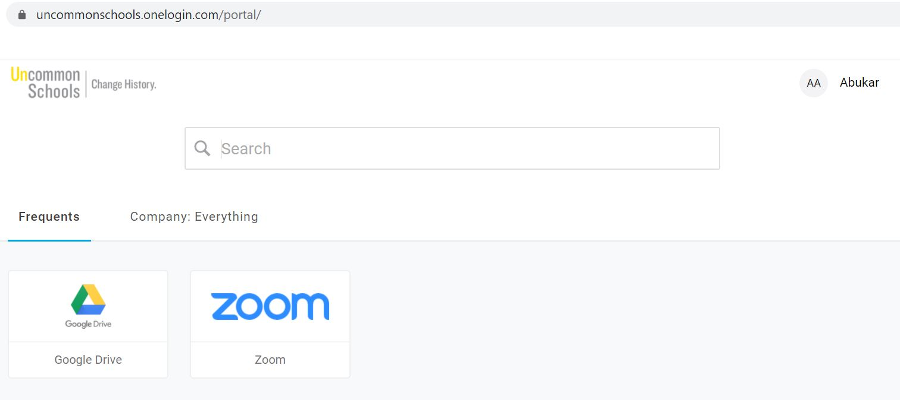

- If they are struggling to access Zoom, have them click on the Zoom icon.

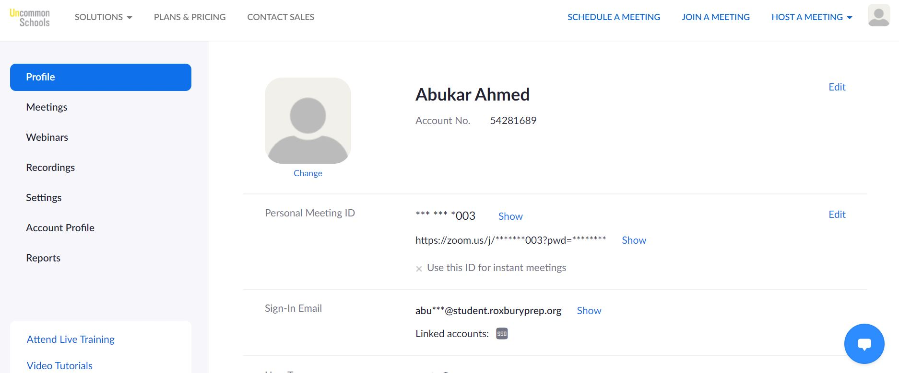
- This will bring them to their Zoom Profile. Have them click on “Join a Meeting” button in the top right part of the screen.

- This will prompt them to enter the meeting ID number which you can provide.
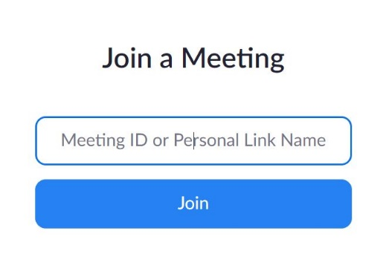

- If they are struggling to access Google Classroom, direct them to click on the Google Drive Icon.

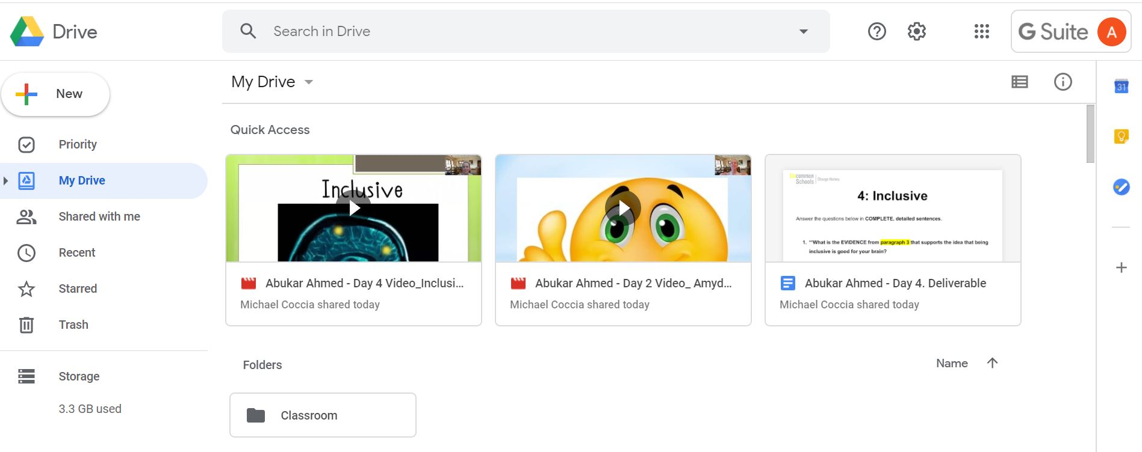
- They will be brought to their Google Drive where they can access MANY different school resources. Have them click on the Menu (9 dots in a square formation)

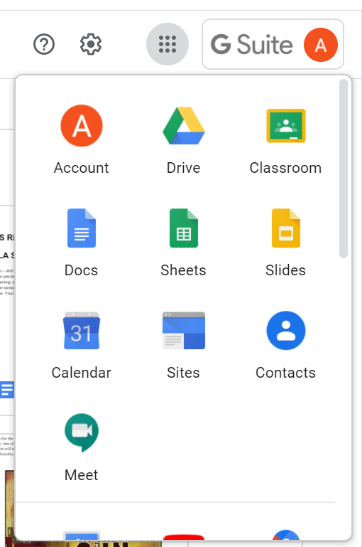
- Then have them click on the classroom icon.

- From there they will be able to see all their classrooms and you can direct them to their Advisory Classroom
